November 19th, 2012
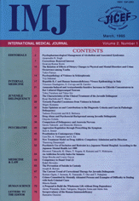
Dr. Onur Hamzaoglu
Department of Public Health
>Kocaeli University Medical Faculty
> Dear Dr. Hamzaoglu :
LETTER OF PAPER ACCEPTANCE
RE: your paper
Air Pollution and Heavy Metal Concentration in Colostrum and Meconium in Two Different Districts of an Industrial City: A Preliminary Report
(paper number: GS-6111240)
We hereby certify that your above paper has been accepted for publication in the IMJ by an editor-in-chief based on peer referee's examination report. It will appear in the near future.
Although this is not an obligation, if any, please include one or two papers previously published in the IMJ (International Medical Journal) in the references, as good and relevant papers are often found in the IMJ. IMJ papers are found on the EBSCO, SCOPUS, and others.

Yours faithfully,

IMJ division
Mr Wataru Uchida
Editorial Office

